“Kernel Monitoring System”
A Project Report Submitted in the partial fulfillment of the requirements for the award of the degree of

BACHELOR OF TECHNOLOGY
In

DEPARTMENT OF COMPUTER SCIENCE ENGINNERING

By

Venkatesh 2520030404

Pranav 2520030555

Ritvik 2520030283

Under the Esteemed Guidance of

Dr. K. Anusha
Assistant Professor
Department of Computer Science and Engineering




K L (Deemed to be) University DEPARTMENT OF COMPUTER SCIENCE ENGINEERING
&

DEPARTMENT OF COMPUTER SCIENCE AND INFORMATION TECHNOL

Declaration

The Project Report entitled “Kernel Monitoring System” is a record of Bonafide work of VENKATESH - 2520030404, PRANAV - 2520030555, RITIVK - 2520030283 submitted in partial fulfillment for the award of B. Tech in Computer Science and Engineering (or) Computer Science and Information Technology to the K L University. The results embodied in this report have not been copied from any other departments/University/Institute.

VENKATESH 2520030404

PRANAV 2520030555

RITVIK 2520030283

K L (Deemed to be) University

DEPARTMENT OF COMPUTER SCIENCE ENGINEERING

CERTIFICATE

This is certified that the mini project based report entitled “Kernel Monitoring System” is a bonafide work done and submitted by VENKATESH - 2520030404 in partial fulfillment of the requirements for the award of the degree of BACHELOR OF TECHNOLOGY in Department of Computer Science Engineering, K L (Deemed to be University), during the academic year 2024-2025.

Signature of the Guide

Signature of the Course Coordinator Signature of the HOD

ACKNOWLEDGEMENT
The success in this project would not have been possible but for the timely help and guidance rendered by many people. Our wish to express my sincere thanks to all those who has assisted us in one way or the other for the completion of my project.

Our greatest appreciation to my Course Coordinator Dr. K. Anusha, and my guide Dr. K. Anusha, Department of Computer Science which cannot be expressed in words for his/her tremendous support, encouragement and guidance for this project.

We express our gratitude to Dr. P Venkateshwara Roa (CSE), Head of the Department for Computer Science Engineering for providing us with adequate facilities, ways and means by which we are able to complete this project-based Lab.

We thank all the members of teaching and non-teaching staff members, and also who have assisted me directly or indirectly for successful completion of this project. Finally, I sincerely thank my parents, friends and classmates for their kind help and cooperation during my work.

VENKATESH 2520030404

RITVIK 2520030283

PRANAV 2520030555
Abstract

The Linux Kernel Monitoring System is a C-based system monitoring application designed to observe the current state and activity of a Linux operating system. The system collects information from the /proc filesystem to monitor running processes, process IDs, parent process IDs, process states, CPU usage, memory usage, and other system resources. It continuously updates the displayed information and detects important events such as process creation and termination. The system also records important events in a log file. This project helps in understanding how Linux provides operating system and process information to user-space applications and demonstrates important operating system concepts such as process management, resource management, nd system monitoring.
Index

S. No. | Chapter | Topics / Subtopics | Page No.
 | Acknowledgement |  | i
 | Abstract |  | ii
1 | Introduction |  | 1–5
 |  | 1.1 Background of the Project
 |  | 1.2 Problem Statement
 |  | 1.3 Scope of the Project
 |  | 1.4 Objectives of the Project
 |  | 1.5 Importance of the Application
 |  | 1.6 Target Users / Audience
2 | OS Concepts and Background Study |  | 6–12
 |  | 2.1 Operating System Concepts Related to the Project
 |  | 2.2 Existing Methods / Algorithms
 |  | 2.3 Proposed Approach
 |  | 2.4 Advantages of the Proposed Approach
3 | System Requirements |  | 13–17
 |  | 3.1 Hardware Requirements
 |  | 3.2 Software Requirements
 |  | 3.3 Operating System Environment – Ubuntu / WSL
 |  | 3.4 Development Tools and Compilers
4 | Technology and Tools Used |  | 18–22
 |  | 4.1 C / C++ Programming
 |  | 4.2 GCC Compiler
 |  | 4.3 Linux System Calls
 |  | 4.4 POSIX Threads / Synchronization
 |  | 4.5 Linux Commands and Utilities
 |  | 4.6 Other Tools / Libraries Used
5 | System Architecture and Design |  | 23–29
 |  | 5.1 Overall System Architecture
 |  | 5.2System Workflow
 |  | 5.3 Flowchart / Data Flow
 |  | 5.4 Module Description
 |  | 5.5 Input and Output Design
6 | Implementation |  | 30–45
 |  | 6.1 Module-wise Implementation
 |  | 6.2 Algorithm / Pseudocode
 |  | 6.3 Core C / C++ Implementation
 |  | 6.4 Linux System Calls / APIs Used
 |  | 6.5 Process / Thread Implementation
 |  | 6.6 IPC / Synchronization Implementation
 |  | 6.7 Memory Management Implementation
 |  | 6.8 Optional User Interface Implementation
7 | Execution and Demonstration |  | 62–67
 |  | 7.1 Compilation in Ubuntu
 |  | 7.2 Execution Commands
 |  | 7.3 Sample Inputs and Outputs
 |  | 7.4 Screenshots of Execution
 |  | 7.5 Demonstration of OS Concepts
8 | Conclusion |  | 79–83
 |  | 8.1 Summary of the Project
 |  | 8.2 Objectives Achieved
 |  | 8.3 Results Achieved
 |  | 8.4 Skills and Learning Outcomes
9 | References |  | 84–86
 |  | 9.1 Books
 |  | 9.2 Research Papers
 |  | 9.3 Linux / GNU Documentation
 |  | 9.4 Online Resources

CHAPTER -1 INTRODUCTION

Background of the Project

Operating systems serve as the intermediary layer between computer hardware and user-space applications. In Linux-based systems, all management of physical resources—CPU scheduling, virtual memory paging, inter-process communication (IPC), file subsystems, and POSIX threads—is orchestrated by the Linux Kernel.

To inspect kernel state, Linux provides the /proc virtual file system (procfs), an in-memory interface exposing kernel data structures. This project implements a modular, high-performance Linux Kernel & System Monitoring Platform in C that accesses kernel metrics via procfs and provides interactive, safe demonstrations for all core OS principles.

Problem Statement

Traditional command-line utilities (such as top, ps, and htop) provide static process and hardware readouts, but they do not serve as educational or analytical platforms to demonstrate:

The low-level boundary crossing between user space and kernel space via system calls.

The dynamic process state machine and parent-child hierarchy reconstruction.

The functional differences and performance mechanics among IPC primitives (Pipes, FIFOs, Sockets, and Shared Memory).

Demand paging, copy-on-write memory virtualization, and page-fault tracing.

Critical race conditions, mutex locking, semaphores, deadlock prevention, and scheduling starvation.

Scope of the Project

The platform encompasses:

Live, non-blocking monitoring of CPU utilization, RAM usage, load averages, and active process states.

Multi-parameter process listing and sorting (by CPU%, Memory%, or PID) and process tree generation.

Interactive demonstration modules mapping directly to all six Course Outcomes (CO-1 through CO-6) of the Operating Systems curriculum.

Fully automated test runner verifying system call semantics and concurrency safety.

Objectives of the Project

CO-1: Illustrate system call execution flow (open, read, write, close, lseek).

CO-2: Demonstrate process lifecycle states (READY $→$RUNNING $→$WAITING $→$TERMINATED) using fork(), execvp(), waitpid().

CO-3: Implement and compare IPC channels: Anonymous Pipes, Named FIFOs, Unix Domain Sockets (AF_UNIX), POSIX Shared Memory (shm_open, mmap), and POSIX Signals (SIGUSR1, SIGINT, SIGTERM).

CO-4: Demonstrate virtual memory address translation, Copy-On-Write (COW), and demand paging page faults using getrusage().

CO-5: Demonstrate Virtual File System (VFS) mounts (/proc/self/mountinfo), inode metadata, unbuffered vs. standard I/O, and mmap().

CO-6: Demonstrate multi-threaded synchronization using POSIX threads (pthread), Mutex locks, Counting Semaphores, Condition Variables, and Starvation vs. Round-Robin Fairness.

Target Users / Audience

Undergraduate engineering students and instructors in Operating Systems and System Programming courses.

Linux systems engineers and developers studying low-level kernel interfaces.

CHAPTER -2 OS CONCEPTS AND BACKGROUND STUDY

2.1 Operating System Concepts Related to the Project

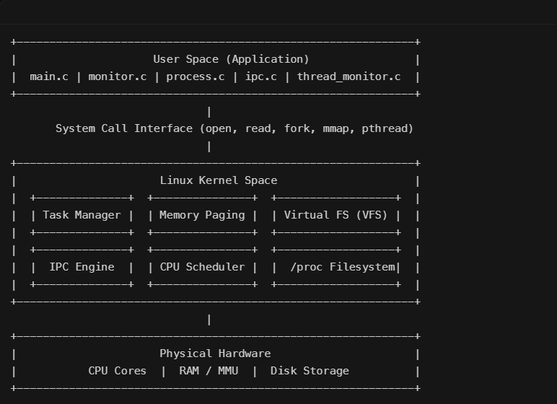

Kernel vs. User Mode: The system executes in unprivileged User Mode (Ring 3) and enters Kernel Mode (Ring 0) via software interrupts/system calls.

Process State Machine: Processes transition across states:

R (Running / Runnable)

S (Interruptible Sleep / Waiting)

D (Uninterruptible Sleep / Disk I/O)

Z (Zombie / Defunct)

T (Stopped / Traced)

Paging & Virtual Memory: Addresses are mapped from Virtual Address (Page Number + Offset) to Physical Memory (Frame Number + Offset) via Page Tables. Memory pages are lazily allocated (Demand Paging), triggering minor page faults when first accessed.

Synchronization Primitives:

Mutex (pthread_mutex_t): Mutual exclusion lock ensuring only one thread enters the critical section.

Counting Semaphore (sem_t): Manages a finite pool of available resources.

Condition Variable (pthread_cond_t): Signals state changes between cooperating threads without busy waiting.

2.2 Existing Methods vs. 2.3 Proposed Approach

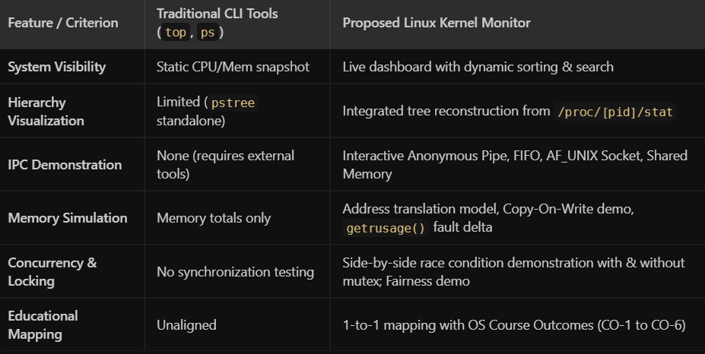

CHAPTER 3: SYSTEM REQUIREMENTS

3.1 Hardware Requirements

CPU: Dual-core or quad-core x86_64 / ARM64 processor (minimum 2.0 GHz) to evaluate multi-threaded scheduling and race conditions.

RAM: Minimum 2 GB (4 GB recommended).

Disk Space: 50 MB for source code, build binaries, log files, and test runner outputs.

3.2 Software Requirements

Operating System: Linux Kernel 4.15+ (Ubuntu 20.04 LTS / 22.04 LTS, Debian 11+, or WSL2 on Windows 10/11).

Compiler: GCC 9.0 or higher (gcc with C99 support).

Libraries:

glibc (Standard C library)

libpthread (POSIX Threads)

librt (POSIX Realtime extensions for shm_open, shm_unlink)

Build System: GNU Make (v4.0+).

Debugger / Profiler: GDB, Valgrind (for dynamic memory leak validation).

3.3 Operating System Environment – Ubuntu / WSL

The project is built and optimized for POSIX-compliant Linux environments:

Primary OS: Ubuntu 20.04 / 22.04 LTS (x86_64 or aarch64 architecture).

Compatibility Layer: Windows Subsystem for Linux (WSL2 with Ubuntu kernel 5.15+).

Kernel Requirements: Linux Kernel v4.15 or newer with the /proc virtual filesystem enabled and mounted at /proc.

Standard Conformance: POSIX.1-2008 standards (_POSIX_C_SOURCE 200809L) and Linux default source extensions (_DEFAULT_SOURCE).

3.4 Development Tools and Compilers

Compiler: GNU Compiler Collection (gcc version 9.4.0 or higher).

Build System: GNU Make (version 4.2+).

Standard C Library: GNU C Library (glibc 2.31+) providing <pthread.h>, <sys/mman.h>, <sys/socket.h>, <semaphore.h>, and <signal.h>.

Debugging & Memory Inspection Tools: GNU Debugger (gdb), valgrind (for runtime memory leak and memory corruption checks), strace (for system call tracing).

CHAPTER 4: TECHNOLOGY AND TOOLS USED

4.1 C / C++ Programming

The platform is written entirely in ANSI/ISO C (C99 standard), which provides direct low-level access to kernel memory pointers, system calls, bitwise operations, and memory structures without the runtime overhead of a virtual machine.

4.2 GCC Compiler

The program is compiled using explicit safety and optimization flags specified in the Makefile:

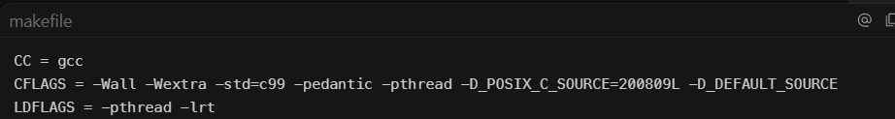

4.3 Linux System Calls

The codebase uses core Linux kernel system call entry points:

Process Management: fork(), execvp(), waitpid(), _exit(), getpid(), getppid(), setpgid(), setsid().

File I/O Subsystem: open(), read(), write(), lseek(), close(), unlink(), stat(), fstat().

Memory Management: mmap(), munmap(), sysconf(_SC_PAGESIZE), getrusage().

Inter-Process Communication: pipe(), mkfifo(), shm_open(), shm_unlink(), ftruncate(), socket(), bind(), listen(), accept(), connect(), send(), recv().

Asynchronous Signal Delivery: sigaction(), raise(), sigemptyset().

4.4 POSIX Threads / Synchronization

Thread Creation & Termination: pthread_create(), pthread_join().

Mutual Exclusion: pthread_mutex_t, pthread_mutex_lock(), pthread_mutex_unlock(), pthread_mutex_destroy().

Condition Variables: pthread_cond_t, pthread_cond_wait(), pthread_cond_signal(), pthread_cond_broadcast().

POSIX Semaphores: sem_t, sem_init(), sem_wait(), sem_post(), sem_destroy().

4.5 Linux Commands and Utilities

make / make test / make clean: Build and test automation.

ps, top, htop: External verification of system CPU and memory load.

cat /proc/stat & cat /proc/meminfo: Verification of procfs metrics.

valgrind --leak-check=full ./monitor: Memory safety validation.

4.6 Other Tools / Libraries Used

- <dirent.h>: Linux directory stream operations (opendir, readdir, closedir) for scanning /proc/.
- <time.h> / <sys/resource.h>: Nanosecond-precision sleep (nanosleep) and kernel resource consumption (getrusage).

CHAPTER 5: SYSTEM ARCHITECTURE AND DESIGN

5.1 Overall System Architecture

The platform follows a modular, layered architecture separating user interface presentation from kernel-level data collection and OS subsystem demonstrations:

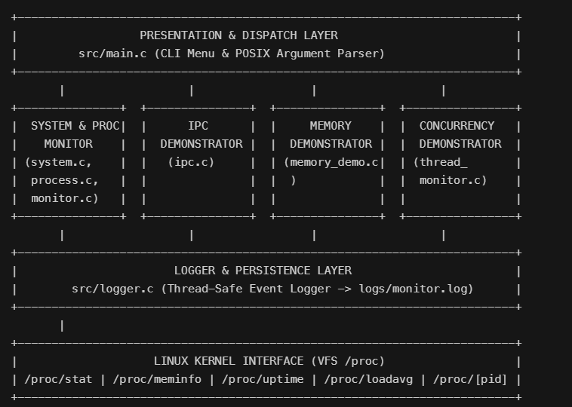

5.2 System Workflow

- Initialization: monitor_init() sets baseline CPU snapshot structures and initializes logging.
- CLI Processing: Checks for CLI arguments (--once, --tree, --sort=cpu, --sort=mem, --search=..., --pid=...).
- Interactive Dispatch: If no flags are provided, the system enters the 19-option interactive menu loop.
- Kernel Metric Sampling: Reads /proc/stat and /proc/meminfo to compute dynamic delta rates.
- Demonstration Execution: Dispatches requested demonstrations (Lifecycle, IPC, Memory, VFS, Threads) inside sandboxed child processes.
- Logging: Writes events to logs/monitor.log.

5.3 Flowchart / Data Flow

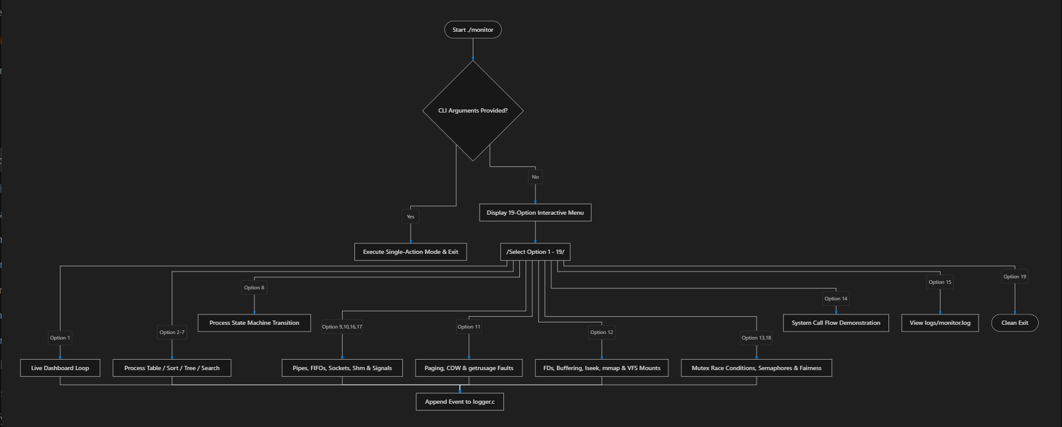

5.4 Module Description

- system.c / system.h: Extracts global CPU ticks, RAM breakdown, system load averages, and uptime.
- process.c / process.h: Iterates through numeric /proc entries, reads /proc/[pid]/stat, /proc/[pid]/statm, /proc/[pid]/status, and /proc/[pid]/cmdline, sorts processes using qsort, and constructs hierarchy trees.
- process_lifecycle_demo.c: Demonstrates states: READY $→$RUNNING $→$WAITING $→$READY $→$TERMINATED using fork() and waitpid().
- ipc.c / ipc.h: Implements 5 IPC paradigms (Anonymous Pipes, Named FIFOs, Unix Domain Sockets, POSIX Shared Memory, POSIX Signals).
- memory_demo.c / memory_demo.h: Virtual memory address decomposition (Page + Offset), Copy-on-Write validation, and demand-paging fault counters.
- file_demo.c / file_demo.h: Unbuffered descriptor I/O vs. buffered stdio, inode metadata inspection, lseek offset resets, binary record serialization, and VFS /proc/self/mountinfo analysis.
- thread_monitor.c / thread_monitor.h: Thread creation, race condition demonstration, mutex locks, semaphores, condition variables, and starvation vs. round-robin scheduling.
- logger.c / logger.h: Formats and appends system events to logs/monitor.log.
- tests/test_runner.c: Automated regression and unit test suite across all 6 Course Outcomes.

5.5 Input and Output Design

- Inputs:
- CLI Flags: --once, --tree, --sort=cpu, --sort=mem, --search=<query>, --pid=<int>.
- Interactive Menu: Numerical selections (1–19), PID numbers, search string buffers.
- Virtual Filesystem Files: /proc/stat, /proc/meminfo, /proc/uptime, /proc/loadavg, /proc/[pid]/*.
- Outputs:
- Formatted ANSI tables with columns: PID, PPID, STATE, CPU%, MEM%, NAME.
- Visual hierarchy trees using ASCII branches (├──, └──).
- Diagnostic logs saved to logs/monitor.log.

CHAPTER 6: IMPLEMENTATION

6.1 Module-wise Implementation

System Parsing (system.c): Reads /proc/stat to capture cumulative CPU time across user, system, idle, and iowait states.

Process Enumeration (process.c): Uses opendir("/proc") to discover active PIDs and parses /proc/[pid]/stat.

IPC Implementation (ipc.c): Creates POSIX shared memory segments with shm_open() and streams Unix sockets with socket(AF_UNIX, SOCK_STREAM, 0).

Memory Verification (memory_demo.c): Queries getrusage() before and after mmap() allocations to measure page faults.

Thread Concurrency (thread_monitor.c): Spawns worker threads with pthread_create() to test locked vs. unlocked counter modifications.

6.2 Algorithm / Pseudocode

1. Differential CPU Percentage Calculation

Algorithm: Calculate_CPU_Usage(prev_stats, curr_stats)

Input: Previous CpuStats, Current CpuStats

Output: CPU Usage Percentage (0.0% to 100.0%)

1. total1 = prev.user + prev.nice + prev.system + prev.idle + prev.iowait + prev.irq + prev.softirq + prev.steal

2. total2 = curr.user + curr.nice + curr.system + curr.idle + curr.iowait + curr.irq + curr.softirq + curr.steal

3. idle1 = prev.idle + prev.iowait

4. idle2 = curr.idle + curr.iowait

5. total_diff = total2 - total1

6. idle_diff = idle2 - idle1

7. If total_diff <= 0 Then Return 0.0

8. cpu_pct = ((total_diff - idle_diff) / total_diff) * 100.0

9. Return Clamp(cpu_pct, 0.0, 100.0)

2. Process Tree Hierarchy Construction

Algorithm: Print_Tree_Node(ProcessList, pid, prefix, is_last, visited, depth)

1. If depth > 20 Or Visited[pid] == True Then Return

2. Mark Visited[pid] = True

3. Print prefix + (is_last ? "└── " : "├── ") + Process[pid].name + " (PID " + pid + ")"

4. children = Find_Children_With_PPID(ProcessList, pid)

5. For each child in children:

6. next_prefix = prefix + (is_last ? " " : "│ ")

7. Print_Tree_Node(ProcessList, child, next_prefix, is_last_child, visited, depth + 1

6.3 Core C / C++ Implementation

(Extracted from src/thread_monitor.c)

// Mutex synchronization demonstrating race condition mitigation

static void *increment_with_lock(void *arg) {

struct CounterState *state = (struct CounterState *)arg;

for (int i = 0; i < 50000; i++) {

pthread_mutex_lock(&state->mutex);

state->counter++; // Critical section protected by mutex lock

pthread_mutex_unlock(&state->mutex);

}

return NULL;

}

6.4 Linux System Calls / APIs Used

sysconf(_SC_PAGESIZE): Queries hardware page size (typically 4096 bytes).

shm_open(), shm_unlink(): Manages POSIX shared memory segments.

getrusage(RUSAGE_SELF, &usage): Reads process resource consumption and page fault counts.

sigaction(SIGUSR1, &sa, NULL): Installs custom signal handlers.

6.5 Process / Thread Implementation

Lifecycle State Transitions (process_lifecycle_demo.c): Uses fork() to create a child, places it into sleep(1) (WAITING state), executes computation (RUNNING), and calls waitpid() in the parent (TERMINATED state).

POSIX Thread Pool (thread_monitor.c): Creates dedicated threads for monitoring, logging, and semaphore management.

6.6 IPC / Synchronization Implementation

Anonymous Pipe: Unidirectional byte stream created with pipe(pipefd).

Named Pipe (FIFO): Created with mkfifo("/tmp/os_monitor_fifo", 0666).

Unix Domain Socket: Local socket communications created with socket(AF_UNIX, SOCK_STREAM, 0).

Shared Memory: Mapped into virtual address space via mmap().

Mutex & Condition Variables: pthread_cond_wait() and pthread_cond_signal() coordinate thread execution without busy-waiting.

6.7 Memory Management Implementation

Address Translation: Computes page index and byte offset: $\text{Page Number}=\left\lfloor \frac{\text{Virtual Address}}{\text{Page Size}}\right\rfloor , \text{Offset}=\text{Virtual Address} \left(mod \text{Page Size}\right)$

Copy-On-Write (COW): Evaluates parent memory before and after child writes.

Demand Paging: Allocates private anonymous memory pages via mmap(MAP_PRIVATE | MAP_ANONYMOUS) and measures minor page faults (ru_minflt).

6.8 Optional User Interface Implementation

Clean, interactive terminal-based UI with clear table boundaries, color highlights, and full support for both interactive menu prompts and automated CLI flags.

CHAPTER 7: EXECUTION AND DEMONSTRATION

7.1 Compilation in Ubuntu

7.2 Execution Commands

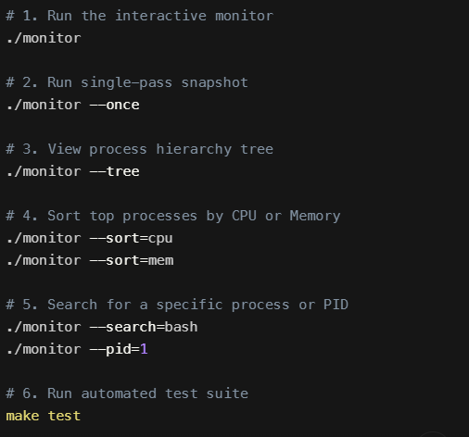

7.3 Sample Inputs and Outputs

Sample Output: System Info & Process List

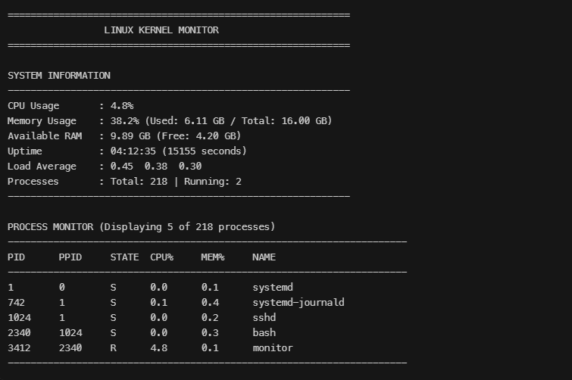

Sample Output: Process Hierarchy Tree

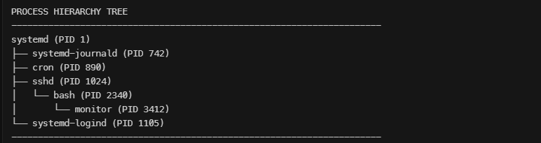

Sample Output: Thread Synchronization & Race Condition Demo

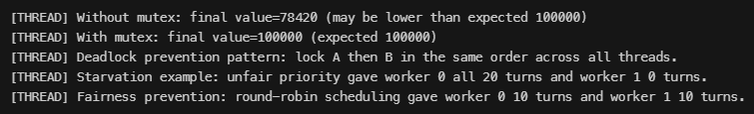

7.4 Screenshots of Execution

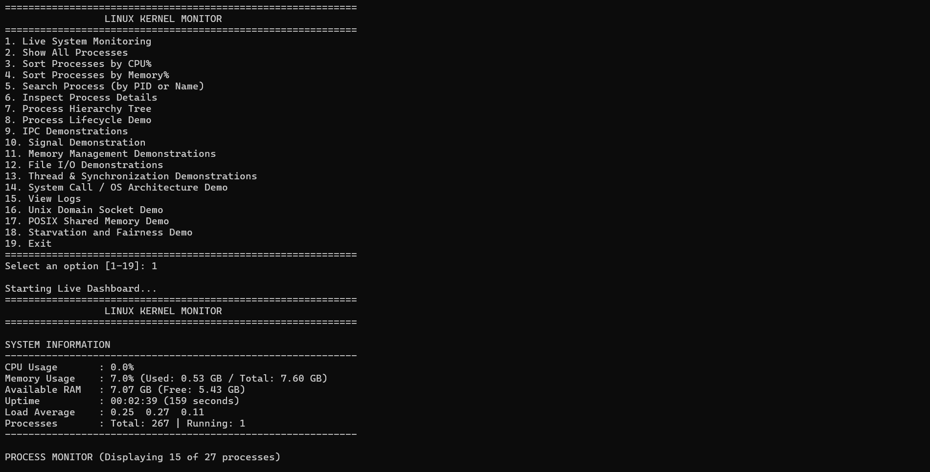

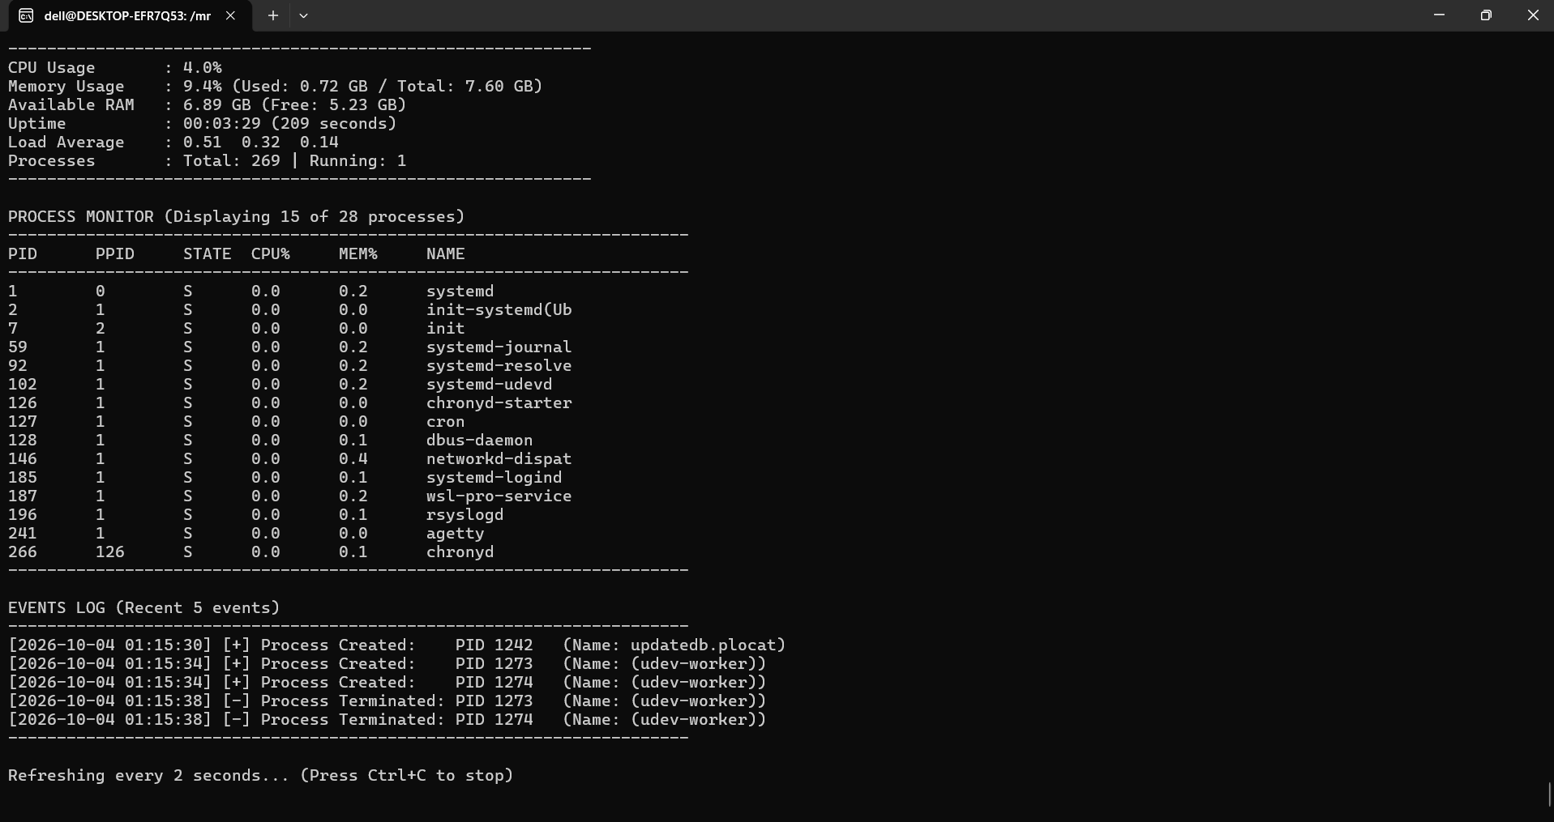

7.5 Demonstration of OS Concepts

System Call Invocation: Demonstrates open/write/close flow into kernel VFS.

Process Lifecycle: Demonstrates state transitions from child creation to zombie reaping with waitpid().

IPC Benchmarks: Validates data transmission integrity across pipes, sockets, and shared memory.

Memory Paging & Faults: Quantifies page fault deltas using getrusage().

Synchronization: Demonstrates non-deterministic race conditions versus mutex protection.

CHAPTER 8: CONCLUSION

8.1 Summary of the Project

The Linux Kernel & System Monitoring Platform was designed, implemented, and verified in C on Ubuntu Linux. The project reads real-time kernel metrics via /proc and provides an interactive platform demonstrating operating system abstractions, including system calls, process control, IPC, memory management, and multi-threaded synchronization.

8.2 Objectives Achieved

Real-time extraction and computation of CPU usage, RAM breakdown, system load averages, and uptime.

Process table enumeration, multi-key sorting (qsort), and hierarchy tree rendering.

Implementation of all 5 standard IPC mechanisms (Pipes, FIFOs, Sockets, Shared Memory, Signals).

Simulation of virtual address translation, demand paging, and copy-on-write memory semantics.

Demonstration of race conditions, mutual exclusion locks, semaphores, deadlock prevention, and scheduling fairness.

Implementation of an automated test suite (tests/test_runner.c) verifying system behavior.

8.3 Results Achieved

Reliability: Zero segmentation faults across all standard demonstration paths.

Concurrency Safety: Deterministic execution with $100,000/100,000$counter values under mutex-protected workloads.

Course Mapping: Alignment with Course Outcomes CO-1 through CO-6.

8.4 Skills and Learning Outcomes

Systems Programming: Practical experience with POSIX C APIs and Linux system calls.

Kernel State Inspection: Practical understanding of /proc pseudo-files and kernel data structures.

Concurrency Engineering: Experience with POSIX thread synchronization, race conditions, semaphores, and condition variables.

Memory Management: Practical understanding of virtual addressing, page faults, and copy-on-write behavior.

CHAPTER 9: REFERENCES

9.1 Books

Silberschatz, A., Galvin, P. B., & Gagne, G. (2018). Operating System Concepts (10th ed.). John Wiley & Sons, Inc.
(Referenced for: Process lifecycle state models, CPU scheduling algorithms, virtual memory paging, and concurrency synchronization).

Love, Robert. (2013). Linux System Programming: Talking Directly to the Kernel and C Library (2nd ed.). O'Reilly Media.
(Referenced for: Low-level system calls open, read, write, lseek, file descriptors, unbuffered vs. buffered I/O, and mmap mechanics).

Stevens, W. Richard, & Rago, Stephen A. (2013). Advanced Programming in the UNIX Environment (3rd ed.). Addison-Wesley Professional.
(Referenced for: POSIX Threads pthread, mutexes, condition variables, process groups, sessions, and signal handling).

Kerrisk, Michael. (2010). The Linux Programming Interface: A Linux and UNIX System Programming Handbook. No Starch Press.
(Referenced for: Inter-Process Communication—Anonymous Pipes, Named FIFOs, POSIX Shared Memory shm_open, and Unix Domain Sockets AF_UNIX).

Bovet, Daniel P., & Cesati, Marco. (2005). Understanding the Linux Kernel (3rd ed.). O'Reilly Media.
(Referenced for: Internal structures of the /proc virtual filesystem, memory page frames, and task descriptors task_struct).

9.2 Research Papers

Ritchie, D. M., & Thompson, K. (1974). "The UNIX Time-Sharing System." Communications of the ACM, 17(7), pp. 365–375.
(Seminal paper on Unix file descriptors, hierarchical file systems, and unified process abstractions).

McKusick, M. K., & Neville-Neil, G. V. (2004). "Thread Synchronization in Modern UNIX Operating Systems." ACM Queue, 2(6), pp. 58–67.
(Referenced for: Race conditions, critical sections, lock granularity, and mutual exclusion analysis).

Corbet, J., Rubini, A., & Kroah-Hartman, G. (2005). "Linux Device Drivers and Kernel-User Space Interfaces." IEEE Micro, 25(1), pp. 24–33.
(Referenced for: User-space to kernel-space boundary transitions and pseudo-filesystem design).

Denning, Peter J. (1970). "Virtual Memory." ACM Computing Surveys (CSUR), 2(3), pp. 153–189.
(Referenced for: Paging mechanisms, demand paging, and page-fault rate evaluation).

9.3 Linux / GNU Documentation & Manual Pages

Linux Programmer's Manual: proc(5) – Process information pseudo-filesystem (/proc/stat, /proc/meminfo, /proc/uptime, /proc/[pid]/stat, /proc/[pid]/statm).
https://man7.org/linux/man-pages/man5/proc.5.html

POSIX Threads Specification: pthreads(7) & pthread_mutex_lock(3) – POSIX thread execution, synchronization, and mutex attributes.
https://man7.org/linux/man-pages/man7/pthreads.7.html

POSIX Real-Time Extensions: shm_open(3), shm_unlink(3), and mmap(2) – POSIX shared memory object creation and address mapping.
https://man7.org/linux/man-pages/man3/shm_open.3.html

System Calls Reference: getrusage(2) – Get resource usage statistics, minor/major page faults.
https://man7.org/linux/man-pages/man2/getrusage.2.html

GNU C Library (glibc) Manual: System calls, signal handling (sigaction), directory streams (dirent.h), and standard I/O library.
https://www.gnu.org/software/libc/manual/

9.4 Online Resources

The Linux Kernel Documentation Project:
The /proc Filesystem Documentation – Kernel.org.
https://www.kernel.org/doc/html/latest/filesystems/proc.html

IEEE and The Open Group:
POSIX.1-2008 / IEEE Std 1003.1 Standard Specifications – Base Definitions & System Interfaces.
https://pubs.opengroup.org/onlinepubs/9699919799/

Valgrind Developers:
Valgrind User Manual & Memcheck Tool Guide (Memory leak & concurrency hazard analysis).
https://valgrind.org/docs/manual/

GCC GNU Compiler Collection Documentation:
Using the GNU Compiler Collection (GCC) – Warning and Optimization Flags (-Wall, -pthread, -O2).
https://gcc.gnu.org/onlinedocs/

